Table of Contents
Getting Started 2
Protecting The Register System Data 3
Setting Up The Register System 3
Allowing The Register System To Run 4
Overview Of The System 5
The Folder Mail Merge Reports 5
The Archive Folder 5
The Main Spreadsheet 5
The Data Spreadsheet 7
Recording Attendance 9
End Of Session Data Clean Up 11
Deleting Attendance Records 12
Deleting People With A Leaving Date 12
The Reports Spreadsheet 13
The Games Boards 14
The Games Boards’ Question Cards 15
The Mail Merge Reports 16
The Mail Merge Data Spreadsheet 16
How To Allocate Groups And Teams 18
A mid-week meeting where the young people normally split up into 2 groups 18
A midweek meeting where the young people normally stay together as a single group 18
Several groups meet at the same time 19
An individual or several members of another organisation visit all groups 19
An individual or several members of another organisation visit only 1 group 20

Getting Started
Welcome to the Excel Register System. This system is free to use and largely customisable.
It was originally created in Microsoft® Access to maintain the register system for a Sunday School of up to 75 young people. It was also used for one of the largest Crusader groups (now known as Urban Saints) in the UK, where the mail merge reports added a touch of professionalism to the communication with both the children and their parents. Most recently I used it to manage the register of my Sunday School group, where the automated games boards proved to be very popular with the young people and encouraged teamwork and discipline.
However, few people have Microsoft® Access these days so from December 2021 I rewrote it in Microsoft® Excel® 365 in my spare time. It may work in other versions of Microsoft® Excel® but I cannot confirm this.
If you are unfamiliar with Microsoft® Excel® there is plenty of online help to get you started or to raise your skill level on particular topics.
It is free to use and largely customisable. It is also ‘open source’ which means that you can view the VBA code plus anyone can see that the code is not going to do anything nasty to your PC.
I have provided a range of Microsoft® Excel® and Mail Merge reports in Microsoft® Word® documents based on what was required elsewhere, but you can create your own and they will be seamlessly included in the list of reports and mail merge documents. If you are feeling really techy you can even create your own games boards to add to the 3 I have provided here.
When you open the register system and navigate around it you will see that I have left sample data in it. This will let you see how the system works and try out the reports and games boards before you overwrite my sample data with your own.
For simplicity I have written this document from the perspective that this system will be used for a youth group. However, it can be used for any group or activity where details about who was present on any given date should be retained.
Recording who was present at each group in your organisation on any particular date could be crucial if the authorities need to know in the future if an individual had any contact with the young people (including if any external groups such as the Fire Brigade or St. John’s Ambulance attended as the individual might have been in that group of people). These records should be retained for several years in accordance with the regulations for your country and organisation, especially those related to data protection (known as GDPR in Europe).
So not only should the young person's attendance be recorded but all leaders, helpers and visitors present on each date should be recorded as well. I suggest external organisations such as those mentioned above could be treated as a single person called by that group’s name rather than having to get the names of every individual in that group (which may not be feasible) as the authorities should be able to cross-reference this with that organisation’s own records.
Also, they type of data you hold about individuals must comply with the regulations for your country and organisation, especially those related to data protection.

Protecting The Register System Data
The spreadsheets in this system are protected by passwords. The initial password is “xxx” which you should change asap using the main spreadsheet to one only known to you and those who are authorised to see the sensitive data that you will add into this system. Passwords should be several characters long and should not include things others could guess based on what they know about you (e.g. names of relatives or pets, hobbies, favourite places).
If there is a suspicion that someone who should not know the password might know what it is the password should be changed to something completely different ASAP.
Also, care should be taken not to leave a PC with this system unlocked when others (young or old) could have access to the PC. You should always lock your PC screen when it is unattended (in Windows hold down the Flag button in the bottom left area on your keyboard and press L). The account used to access this system should be password protected

Setting Up The Register System
The first thing you need to do is to open Windows Explorer and create a folder for this system. Ideally this should be a folder that only those who are allowed to see the sensitive data in this system can access. This system should work in a shared folder in the cloud, but I cannot confirm this.
You can have more than one Register System on your PC to cover registers for different groups (e.g. ones that meet on a Sunday and others that meet midweek). To do this install the register system into different folders. The system will automatically update the folder where the spreadsheets are stored as long as you open them from the main spreadsheet.
Download the zip file in my web site’s page and move it into the folder(s) you have set up. Then open the zip file in the folder and extract the files and folders within the zip file back to the folder for this system (any zip file app you may have on your PC will have its own way of doing this – the default one with Windows allows you to select everything, press CTRL-C to copy the files and folders, return to the folder for this system and press CTRL-V to paste everything in the zip file into it).

Allowing The Register System To Run
To use this you should mark this folder as a Trusted Location and Enable Macros. To do this:
- Open Microsoft® Excel®
- Select File > Options > Trust Center
- Press the button Trust Center
- Select Trusted Locations
- Press the button Add New Location and add the folder you created for this system
- Select Macro Settings
- I recommend you select the second radio button:
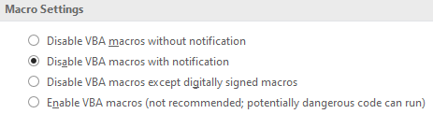

Overview Of The System
There are 2 subfolders in the main Register System folder:
- Mail Merge Reports
- Archive
There are 4 spreadsheets in the main Register System folder:
- The main spreadsheet (Register System.xlsm)
- The data spreadsheet (Register System Data.xlsm)
- The reports spreadsheet (Register System Reports.xlsm)
- The mail merge data spreadsheet (Register System Mail Merge Data.xlsx)

The Folder Mail Merge Reports
The mail merge documents are stored in this folder. Other files can also be put into this folder but only those that are “.docx” files will be listed in the list of mail merge reports in the reports spreadsheet.

The Archive Folder
If you have set Create An Archive to Yes in sheet Organisation Details in the Main spreadsheet and / or you copy-paste any of the spreadsheets to create your own archive you can move them into this folder to keep the main folder uncluttered.

The Main Spreadsheet
The main sheet has 10 buttons that allow you to maintain the data:
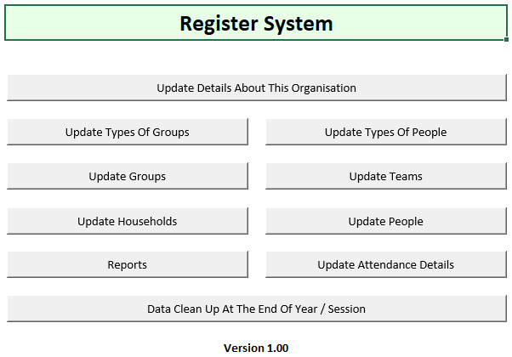
The first time you use this system you should start with the top button and progress down through the others to set up the data for your organisation and groups.
When the button Update Details about This Organisation is pressed the only other sheet that is within the Main spreadsheet is displayed:
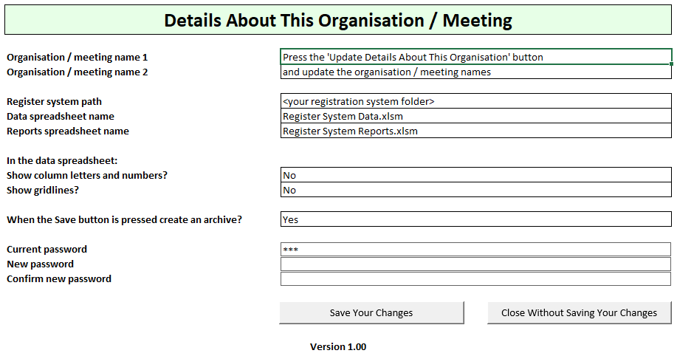
- You should populate the first 2 fields with the name of the organisation. You should enter the name of the generic organisation in the first cell (e.g. “My Church”, “Boys' Brigade & Girls' Association”) and the second cell could contain the name of the meeting this Register System covers (if different) or it can be left empty - these headings will be shown as the headings in the various sheets you will open.
- The register system path will be updated automatically to be the folder where the Main spreadsheet is located and is referenced when the other spreadsheets are opened – you shouldn’t change it.
- The next 2 cells will show / hide Excel’s gridlines and the row & column headers when the sheets in the data spreadsheet are opened – leaving these as “No” looks nicer.
- You can choose to allow the system to create archives when a sheet in the Data spreadsheet is closed – if you leave this as “Yes” then you will have archive files you can open at a later date to check something (which may also prove useful to anyone who has good reason to check when a young person’s home address changed, for example.
- The 3 password fields are not cells within the sheet - they are special controls that allow the password you enter to be masked by asterisks – you need to click in the New and Confirm ‘cells’ with your mouse to enter a new password (when the Save button is pressed the password will be updated in the Main, the Data and the Reports spreadsheets).
When you press the Reports button in the main sheet the reports spreadsheet is populated with the data in the Data spreadsheet and then the Reports spreadsheet is opened showing the sheet with the list of available reports (including the games boards).
When you press any of the other buttons in the main sheet the appropriate sheet in the Data spreadsheet is opened.

The Data Spreadsheet
This spreadsheet holds all of the data apart from the generic data entered into sheet Organisation Details in the Main spreadsheet.
Within each data sheet there is a data table. You can insert / hide rows and columns above each of these data sheets (e.g. to add a logo). You can also change column widths. However, you must never insert / delete columns within the data table area as this is likely to cause the Reports spreadsheet to error – if there is a column you will never populate just hide that column.
Each data sheet has a hidden row at the top of its table just below the orange row of headings. This hidden row holds the formulae required by the reports and also data validation controls - it is OK to delete any visible row(s) in the table by selecting the row(s) you want to delete, pressing the right-click button on your mouse, selecting Delete and then selecting Whole Row, but you must never unhide the hidden row at the top of the table and delete it (this row is highlighted in yellow with red text so it should be obvious which one that is should you see it).
The screen shot below shows the Teams sheet as an example (note that the first two rows are what is shown in sheet Organisation Details in the Main spreadsheet.
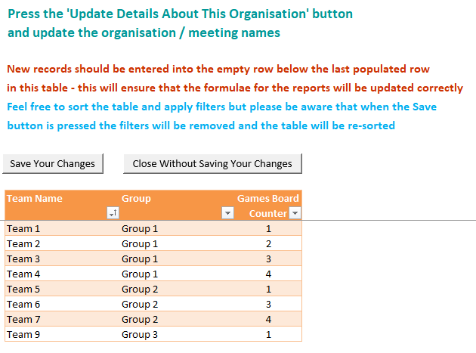
To add new data simply populate the cells in first empty row after the last row in the data table. Excel will then automatically copy into the new row:
- The standard formats of each cell
- The formulae in some cells (most of these are in hidden columns)
- The data validation checks in each cell for numbers, dates and cells referencing data in another sheet (e.g. groups, teams, people - the cell will show a drop-down arrow).
The first column in the data table (the first 2 in a couple of them) must be populated and must be unique. If the cell changes to yellow text on a red background then this ID is not unique and must be changed – the Save button will alert you if you have an empty Unique ID or a duplicate Unique ID and your changes will not be saved until you correct this.
While you can save the spreadsheet using Excel’s own File > Save facility this won’t check the data or create an archive file, and you could have problems / inaccurate data when you try to open the Reports spreadsheet or any of the reports within it.
When the Save button is pressed any column filters you have applied will be cleared and the data table will be re-sorted by the first 3 columns, so if you have sorted it yourself it may appear different when you reopen it.
The sheet Groups has a number of fields specific to the game boards such as the normal game board for that group and any extra points you might want to award that group (see my sample data for examples of this). When deciding how high to make the points for attendance and the extra points you should factor in how many points could be accumulated for everyone within a team over the lifetime of the games board (probably the full year that your organisation meets) and which games board you have selected for the group. The maximum points that each of the 3 games board can represent for a team are noted in the section The Games Boards below.
Also, when selecting the games board used for a group, be aware that some age groups or people groups may not be able to tolerate games boards where points can be lost.
When the young people are allocated to Teams then the games boards can be run at each meeting - combined with the Extra Points this can promote:
- Good behaviour
- The type of behaviours you wish to promote (e.g. bringing a Bible)
- Teamwork
- Healthy competition
To achieve this you will see in my sample data that I awarded each young person a set number of behaviour points which they got as soon as they arrived. They lost some / all of these points if their behaviour / conduct fell below an acceptable level - this proved to be a really effective way to achieve the 4 goals above.
The sheet Households holds the data for a household such as the address. This avoids you having to re-enter the same address for young people who live at the same address.

Recording Attendance
To record attendance press the button Update Attendance Details in the main sheet. This will open the sheet Update Attendance in the Data spreadsheet:
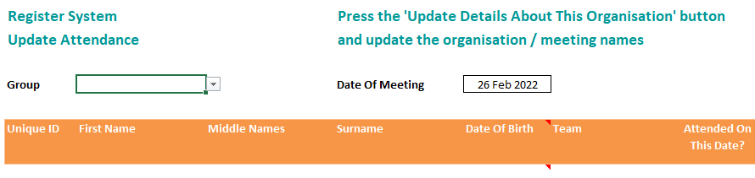
When a Group is selected the people in that group will be listed who:
- Do not have a leaving date
- Have been allocated to a Type Of Person that allows attendance details to be recorded.
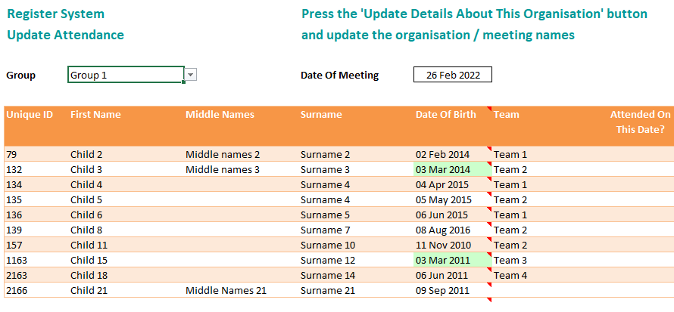
In addition to what you see in the screen shot above there are columns to the right of the Attended On That Date column that show the Extra Points you have specified for that group:
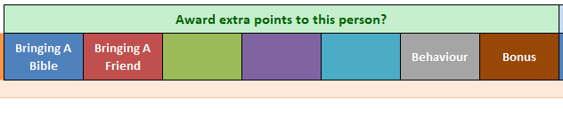
When you enter a “Y” against any person and enter a “Y” against any of their Extra Points the default number of Extra Points specified for that group is allocated to that person. The number of points shown can be changed to another positive number – these are only the group’s default values (e.g. if the behaviour is below the acceptable standard then you can reduce the number of Behaviour points, or if they do something to merit Bonus points you put a “Y” in the first Bonus column and specify the number of points in the second Bonus column).
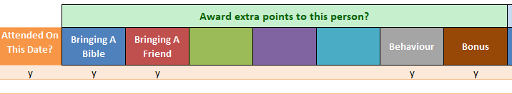
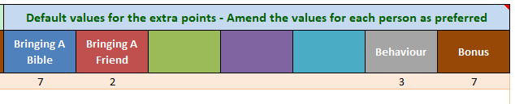
When the button Save is pressed the rows where Attended On That Date? is “Y” will be added to the hidden sheet Attendance. The specified number of points where Award Extra Points is set to “Y” will be included in that record.
When recording attendance note that, when the button Save is pressed, existing records for that group on that date will be cleared – if you want to amend the attendance of the group on a date where their attendance has already been recorded the full attendance record for that week will needs to be recorded, including any extra points they were awarded.
Alternatively, if the change is a minor tweak to an existing record (e.g. it transpires that they earned their bonus points by cheating) it might be easier to press the button Open The Attendance Data Sheet, to scroll down to that group’s record on that date, and to amend the appropriate cell manually. Note that in sheet Attendance you may see records where:
- The People ID is “*** GBA ***”
- The First Name is “Games Board Adjustment”
- The Middle Name is “(Cursor movements arising from question cards in Game Boards)”
These should not normally be changed – they are the number of squares the team gained in the game boards by answering a question correctly (or even lost by answering it incorrectly in the Snakes & Ladders games board when that team’s counter landed on a snake), and additionally in the Monopoly game board when a square is landed on that has a predefined movement (i.e. “Go to the next railway station” or “Return to the naughty step”).

End Of Session Data Clean Up
At the end of each session / year you will probably want to clear down
- People who left a long time ago and are highly unlikely to attend again
- Attendance records for the year
While you can do this manually in the respective sheets this facility allows you to do this quickly and safely.
Before doing this you should ensure you have printed any end of year reports you will need to retain and ensure that you have a copy of the Data spreadsheet suitably named to indicate that this backup was taken before the data clean up was done to make it clear several months / years from now.
When you press button Data Clean Up At The End Of Year / Session this screen will be displayed:
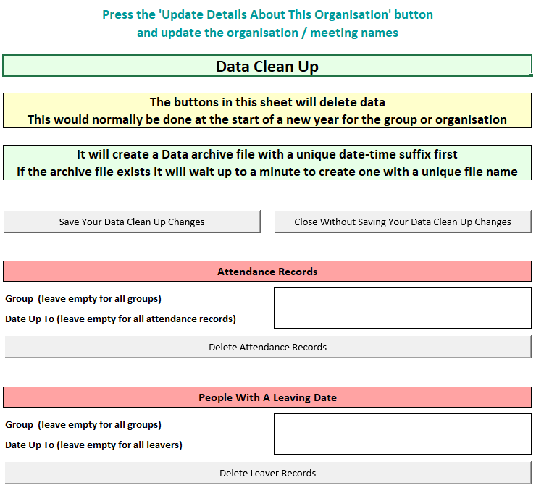

Deleting Attendance Records
To delete the attendance records for a whole group select the group. If you leave this cell unpopulated the attendance records for all groups will be deleted.
To delete attendance records up to a specific date enter that date. If you leave this cell unpopulated all attendance records will be deleted.
If you select a group and enter a date then only the attendance records for that group up to that data will be deleted.
When you press the button Delete Attendance Records then the sheet Attendance will be cleared, taking into account what has been entered in the previous 2 cells. However these changes will not be saved until the button Save Your Data Clean Up Changes is pressed.

Deleting People With A Leaving Date
To delete the leaver records for a whole group select the group. If you leave this cell unpopulated the leaver records for all groups will be deleted.
To delete leaver records up to a specific leaving date enter that date. If you leave this cell unpopulated all leaver records will be deleted.
If you select a group and enter a date then only the attendance records for that group up to that data will be deleted.
When you press the button Delete Leaver Records then the sheet People will be cleared, taking into account what has been entered in the previous 2 cells. However these changes will not be saved until the button Save Your Data Clean Up Changes is pressed.

The Reports Spreadsheet
When this spreadsheet is opened from the main spreadsheet the data stored in this spreadsheet for the reports will be updated from the Data spreadsheet and then the main sheet in this spreadsheet showing the list of the available reports will be displayed:
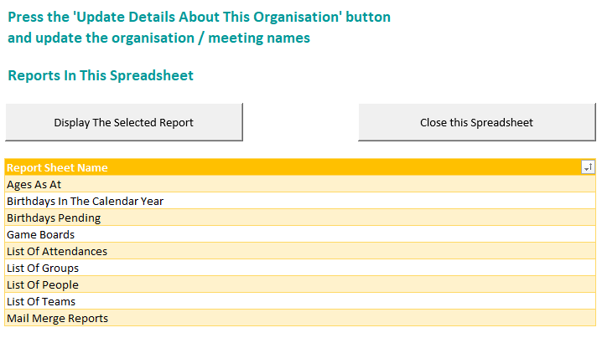
The list of reports shown here is updated automatically with all of the sheets within this spreadsheet that are not system sheets. This means that you can freely add more sheets into this spreadsheet and create your own reports in those sheet. If you do this then you should also copy-paste the Return To The List Of Repoprts button from another report sheet so that you can easily return back to this sheet from your own report.
Some of the reports allow you to select a specific group, to specify dates to narrow the scope of the data shown, and to change the sort order. The sort orders are held in tables in the hidden sheet Sort Orders (you can add extra entries to the sort order tables if you would find additional sort orders useful – just unhide the sheet by right-clicking on the tab for the sheet you are in, select Unhide and select sheet Sort Orders).
When a report in the list is selected press button Display The Selected Report to open the sheet with that report in it.
You can insert rows and columns above the reports (e.g. to add a logo). You can also change column widths. However, you must never insert / delete columns within the report as this could cause problems – if you don’t want to see a column simply hide it. You must never delete rows above the report as some sheets have cells with formulae that are in columns that are hidden.
If a person is not listed in a report that you expected to be there are 3 things that you can check about this person’s record:
- Do they have a leaving date
- Are they allocated to a Type Of Person that excludes them from this type of report
- Are they in a Group where the Type Of Group excludes them from this type of report
When the Close button is pressed you will be asked if you want to save any changes you might have made to this spreadsheet.

The Games Boards
When you select “Games Boards” from the list of reports another sheet will be displayed that will let you select the game board to run.
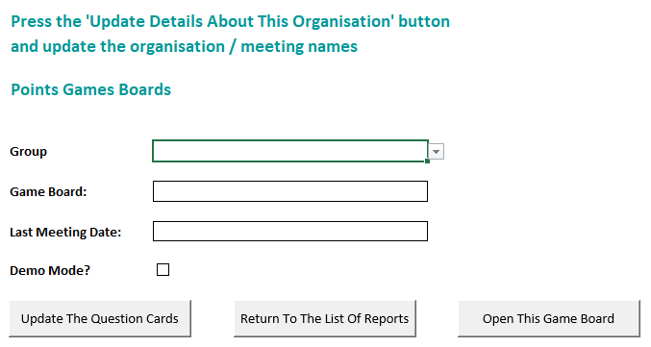
Before you run any of the games boards for the first time for each group you should press the button Update The Question Cards and set up questions that are suitable for this group (see The Games Boards’ Question Cards below).
To open a game board select the group, select a game board (this will default to the one for allocated to this group), change the date of the last meeting if you want to start from an earlier date than the default (this date will be defaulted to the date of the last registration entry for that group and wouldn’t normally be changed), and press the button Open The Games Board.
When you click the Demo Mode check box additional fields will be displayed that will let you run the game board from a starting number of points (the four team counters will be in those cells when the game board is opened) to any final number of points (the counters will move to those positions when button Run The Game Board is pressed) – this will let you try out each of the game boards for yourself and also to demo it to the young people at the start of a session before you start using it for real (any adjustments arising from the question cards for example will not be saved back to the Data spreadsheet).
The button Open The Games Board will display the sheet for the specified game board with the counters for the active teams positioned where they were before the Last Meeting Date.
Press the Run Game Board button to move the counters from their starting position to the total number of points for that team. When a team’s counter passes the last square in the game board a special counter will be displayed outside the game board. As the team completes additional circuits of the game board more of these special counter will be displayed until the maximum number of points the game board can display for a team is finally reached:
- Ludo it’s 2,150
- Monopoly it’s 2,560
- Snakes and ladders it’s 2,500
If a games board is not central enough on your display there are 2 wide columns on either side of the actual game board whose width can be adjusted to get the desired effect:
- Select View from the ribbon at the top of the screen
- Tick the Headings checkbox to see the column headings
- Adjust the column widths (note that when you hide the column headings again the display will move a little to the left so this should be factored in)
- Untick the Headings checkbox

The Games Boards’ Question Cards
The question cards are displayed when the team's final score lands their counter on a "?" square. At this point a random question from a list of questions you have created in advance for that group will be displayed.
If there are no questions in sheet Question Cards for that group nothing will happen when the counter stops on a “?” square (which might be more appropriate for some age groups).
To populate the list of questions that will be displayed for a group press the button Update The Question Cards in the game board selection sheet (see the screen shot above).
The values in the first 2 columns in the Question Cards table must be unique. If they are not unique it will be formatted with yellow text on a red background.
When a game board is being run and a counter lands on a question is displayed the pop-up message with the question has 3 buttons:
- Yes – Press this button if the team answers the question correctly
- No - Press this button if the team does not answer the question correctly
- Cancel - Press this button if the question is not one that team could reasonably be expected to answer (e.g. "How many young people were here last week" when they have just returned from a half-term / end of term break) - a different question will then be displayed
If you press either Yes or No and you have populated the cell for the possible answers in the Question Cards table then this will be displayed in a pop-up message.

The Mail Merge Reports
When you select “Mail Merge Reports” from the list of reports this confirmation prompt is displayed.
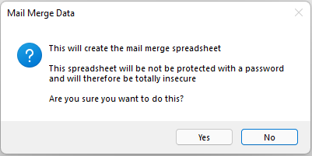
When you press Yes the Mail Merge spreadsheet will be updated, and a sheet will be displayed listing all of the Word documents in the folder Mail Merge Reports.
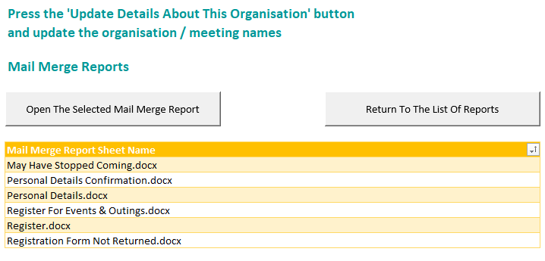
When a report in the list is selected press button Open The Selected Mail Merge Report to open the selected Word document. Note that you will be prompted with 1 or more prompts asking you to select a data source – simply follow the prompts to select the Mail Merge Data spreadsheet and the People sheet within that spreadsheet (all of the sample mail merge reports I have provided reference the People sheet).
You can create your own mail merge Word documents (e.g. to create a note to each child / parent / guardian about an up and coming event, possibly with a line the parent / guardian is to sign to authorise the young person’s attendance). If you are unsure how to do this there is plenty of help online to assist you.

The Mail Merge Data Spreadsheet
This spreadsheet has had to be created without a password. If the sheet is given a password the mail merge reports can fail to recognise it as a data source. As this contains sensitive data, unless your register system is already in a secure folder that only authorised people can access, you should delete this spreadsheet after you have finished creating your mail merge data reports. It will be re-created automatically the next time you select Mail Merge Reports from the list of reports anyway.

How To Allocate Groups And Teams
Here are suggested solutions to 5 scenarios to give you an idea how you might set up the Organisation, Types Of Group, Types Of People, Groups and People:
- A mid-week meeting where the young people normally split up into 2 groups (e.g. the Boys' Brigade & Girls' Association)
- A midweek meeting where the young people normally stay together as a single group
- Several groups meet at the same time (e.g. a Sunday School with several age groups)
- An individual or several members of another organisation visit this organisation and see all groups at the same meeting (e.g. The Fire Brigade, St. John's Ambulance)
- An individual or several members of another organisation visit this organisation and only visits one of the groups

A mid-week meeting where the young people normally split up into 2 groups
In the main spreadsheet press the button Update The Organisation Details and change the 2 Organisation Name lines to something like "The Midweek Group” And “Teenage Boys And Girls".
Create 2 Types Of Group records (1 for the girls' group and 1 for the boys' group) in case the 2 groups should require different settings in the future.
Create 2 groups (1 for the boys and 1 for the girls) setting the Type Of Group to the one for this group.
Optionally create up to 4 teams for 1 or both groups to promote competition etc. by running 1 of the game boards during the meeting.
Create 3 Types Of Person records:
- 1 for the young people
- 1 for the group leaders
- 1 for any helpers

A midweek meeting where the young people normally stay together as a single group
In the main spreadsheet press the button Update The Organisation Details and change the 2 Organisation Name lines to something like "My Church” and "My Midweek Youth Group".
Create 1 Types Of Group record.
Create 1 group for both boys and girls.
Optionally create up to 4 teams for the group to promote competition etc. by running 1 of the game boards during the meeting.
Create 3 Types Of Person records:
- 1 for the young people
- 1 for the group leaders
- 1 for any helpers

Several groups meet at the same time
In the main spreadsheet press the button Update The Organisation Details and change the 2 Organisation Name lines to something like "My Church” and “Sunday School".
Create a Type Of Group record for each type of group (e.g. Pre-School, Pre-Teens and Teenagers – see my sample data).
Create a Group for each of the age groups, setting the Type Of Group to the appropriate one for this group.
Optionally teams can also be created for 1 or more groups to promote competition etc. by running 1 of the game boards during the meeting.
Create 5 Types Of Person records:
- 1 for the pre-schoolers
- 1 for the pre-teens
- 1 for the teenagers
- 1 for the group leaders
- 1 for any regular helpers

An individual or several members of another organisation visit all groups
Create a Type Of Person called "Visitor" and set Record Their Attendance to "Yes".
Create a Group called "Visitors".
Create a People record for this visitor or their organisation (where the first name / surname could be "The My Town Fire Brigade", "The Other Town St. John's Ambulance"), setting the Type Of Person to "Visitor" and the Group to "Visitors".
When recording their attendance:
- Select the group "Visitors"
- Ensure the date is the date of the meeting
- Mark this visitor as having attended with "y"
- Press the Save button

An individual or several members of another organisation visit only 1 group
Create a Type Of Person called "Visitor" and set Record Their Attendance to "Yes".
Create a Group called "Visitors".
Create a People record for this visitor or their organisation (where the first name / surname could be "The My Town Fire Brigade", "The Other Town St. John's Ambulance"), setting the Type Of Person to "Visitor" and the Group to "Visitors".
When updating their attendance:
- Select the group "Visitors"
- Ensure the date is the date of the meeting
- Change the Group This Week in the row for this visitor to the Group they actually attended
- Mark this visitor as having attended with "y"
- Press the Save button

